**Introduction**

On January 10, 2022, the World Health Organization announced the outbreak of Covid19 that plagued countries all over the world from Asia to Africa and also America. The rate that Covid escalated was very astonishing leaving countries to respond by combating the outbreak from further spreading. Some responses that countries made were non-economic factors such as border control, social distancing. The pandemic affected economics worldwide and our group was interested in how economies changed based upon a country’s COVID-19 response .We will use classification methods to sort out countries and along with their response groups.

**Data Introduction**

The dataset that was chosen was from the World Bank Data catalog website and also the name of the dataset is called World Development Indicators. This dataset is about the numerical measure of quality of life in a country. The indicators are used to illustrate the progress of a country in meeting a range of economic, social and environmental goals. However Covid-19 played a huge factor in the economic sectors in countries and it was up to the countries' responses to Covid that dictated the future. There was a lot of data given in the dataset because of the amount of countries around the globe. However we want to only analyze the data for countries represented by the G20 organization, and specifically only economic indicators. Also since Covid-19 was known to appear at the start of 2020 and beyond so from 1964 to 2019 the information was unnecessary and all countries that were not a part of the G20 needed to be cleaned up since the G20 is the target population. In this data set there were alot of null values and that needs to be cleaned up along with the year 2021 so that year will also be dropped.

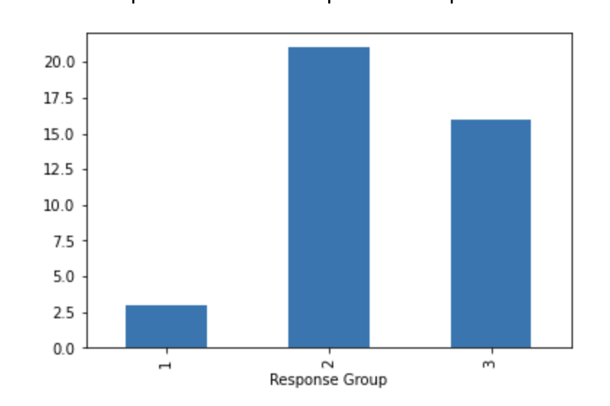

The countries in the G20 section were organized in a bar graph and it shows which countries are assigned to their response group. One can tell by the picture of the data that it is not balanced. The data favors response group 2 and 3 however data will have to be tested and trained in order to view the metrics of different methods performed on data.